**PE**

Develop flexibility, strength, technique, control and balance through gymnastics

**GEOGRAPHY**

**ART AND DESIGN**

• exploring the qualities of tones with watercolour paints and chalk pastels

• making observations and looking closely at the lines we can see

• using and exploring clay to create ‘pinch pots’

• finding out about and working in the style of artist Andy Goldsworthy

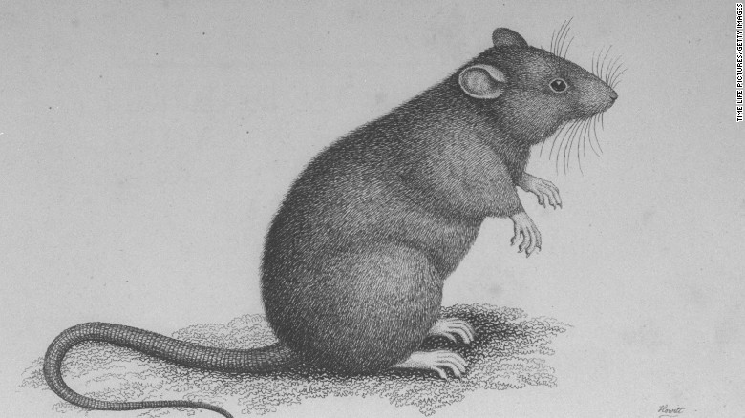

**HISTORY**

**The Plague**

British history in the 1600s – the effect and impact of the plague.

**BRITISH VALUES**

* Re-election for the school council.

**Measurement**

* convert between different units of metric measure (for  
  example, kilometre and metre; centimetre and metre;  
  centimetre and millimetre; gram and kilogram; litre and  
  millilitre)
* solve problems involving converting between units of  
  time.

**Addition and subtraction**

* add and subtract whole numbers with more than 4 digits, including using formal written methods (columnar addition and subtraction)
* add and subtract numbers mentally with increasingly large numbers
* use rounding to check answers to calculations and  
  determine, in the context of a problem, levels of accuracy
* solve addition and subtraction multi-step problems in  
  contexts, deciding which operations and methods to use and why

**Measurement**

* use all four operations to solve problems involving measure [for example, length, mass, volume, money] using decimal notation including scaling

**Statistics**

* solve comparison, sum and difference problems using information presented in a line graph
* complete, read and interpret information in tables including timetables.

**Number and place value**

* read, write, order and compare numbers to at least  
  1 000 000 and determine the value of each digit
* count forwards or backwards in steps of powers of 10 for  
  any given number up to 1 000 000
* round any number up to 1 000 000 to the nearest 10, 100, 1000, 10 000 and 100 000
* solve number problems and practical problems that involve all of the above

**Multiplication and division**

* multiply and divide whole numbers and those involving  
  decimals by 10, 100 and 1000

**Fractions (including decimals and percentages)**

* read and write decimal numbers as fractions [for example, 0.71 = 71∕100]
* recognise and use thousandths and relate them to tenths, hundredths and decimal equivalents
* round decimals with two decimal places to the nearest  
  whole number and to one decimal place
* read, write, order and compare numbers with up to three  
  decimal places
* solve problems involving number up to three decimal places

**MATHS**

**English & Spelling / Grammar**

* Fairy tales set in the 1600s – The Pied Piper. Story telling into writing, the children will innovate and then invent their own 1600s fairy tales. (3 weeks).
* News paper reports based on the history of the plague. Written from the perspective from someone within the plague – eyewitness accounts. (2 weeks)
* Instruction writing on how to survive the plague (2 weeks).
* Cinquain poetry on the plague (2-3 days)

**SPaG**

* Indicating degrees of possibility using adverbs [for example, perhaps, surely] or modal verbs [for example, might, should, will, must]
* Converting nouns or adjectives into verbs using suffixes [for example, –ate; –ise; –ify]
* Verb prefixes [for example, dis–, de–, mis–, over– and re–]

**Reading**

* Group guided reading

**COMPUTING**

Researching the plague using ICT.

Type up poems in neat.

**Seasonal Enrichment**

* House day
* Outdoor learning
* 50 experiences opportunities

**Religious Education**

GOD

What does it mean if God is holy and loving?

Understanding Christianity upper KS2 unit.

Harvest.

**MUSIC**

**SPIRITUALITY**

* School values
* Windows, mirrors and doors
* Harvest celebrations
* What makes me unique/special

**SCIENCE**

**Forces**

* Identify forces acting on objects
* Measuring the force of gravity pulling on objects
* Investigate air resistance
* Investigate water resistance
* Identify the effects of friction
* Explore and design a simple mechanism

|  |  |  |  |
| --- | --- | --- | --- |
| **St Uny C of E Academy** Image result for aspire academy trust | | | |
| **Term: Autumn 1** | **Year: 2019/20** | **Teachers: Mr Smith** | **Year Groups: 5** |
|  | **TOPIC: The Plague** | | |
|  | | | |