name
class | Wheal Dream Year 5
TERM | Autumn Term 1
TOPIC | The Great Plague
TOTAL POINTS
Take Away Homework!
Choose your homework from the menu below. the peri-ometer shows you the level of challenge. You need to reach a minimum of ten points to achieve your homework target for the half term!

6 Points
5 Points
4 Points
3 Points
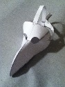  Make a plague doctor’s mask using any material of your choice | Some people believe the nursery rhyme 'Ring-a-ring-o'-roses' is linked to the plague. Research why people think this and write if you agree and explain your reasons. | Some people believed that holding a small bunch of flowers in front of your nose would prevent you from catching the plague.  See if you can use your baking skills to bake something in the shape of a flower!
Make an A-Z list based on The Great Plague. Think about presenting your work in the best way possible. You could add illustrations or photos to each of the letters. | Write a diary entry as a child stuck in London during 1665. Make clear your feelings and the events taking place around you. | Research why the plague doctors dressed the way they did. Draw a picture and label their outfit.  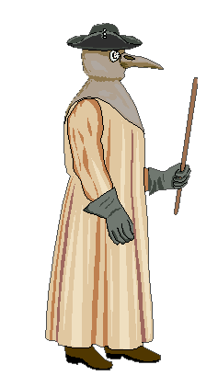
Write an acrostic poem about the plague.  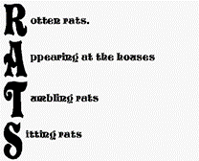 | Invent your own medicine as a remedy for the plague. You can write about this, make it using liquids or design a bottle with labels stating what it contains. Take photographs of your creation! | Any houses that were infected with the plague were marked with a red cross on the door. Design your own symbol and phrase to make people aware that a household has the plague!
Sketch a detailed drawing of a rat. | Research 5 interesting facts to share with the class about the plague. | Imagine you are a plague doctor. Create a list of top tips needed in order to avoid catching the plague.

