Return date | Task | Complete
Friday 28th September  28.09.18 | Make a small memory box of some of your favourite things that you would like to share with everyone at school.  Think about why they are special to you.
Friday 12th October  12.10.18 | At home, help to make a healthy meal, thinking about the healthy lifestyle choices that we must make.  It would be lovely to see some photos of your delicious food and for you to tell me what you made.
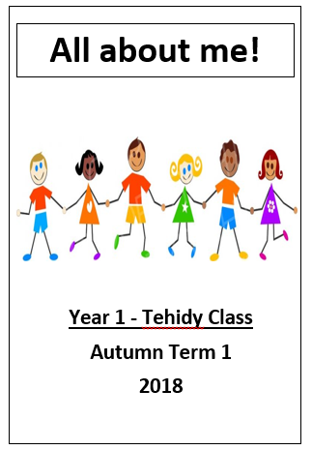
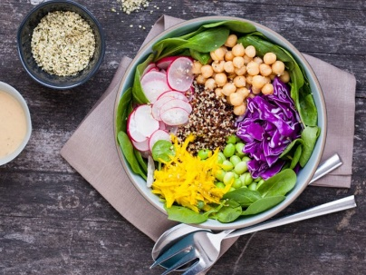
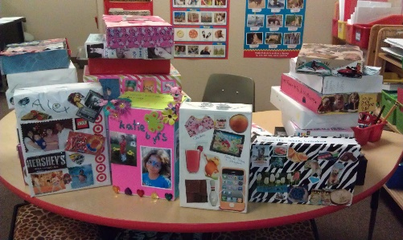
Tehidy – Homework topic grid: Autumn 1

