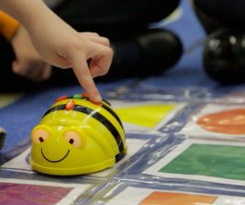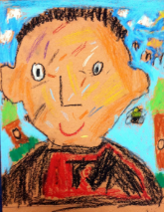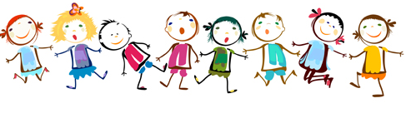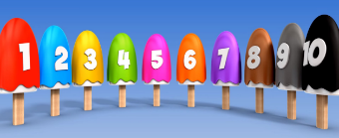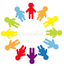

**In History we will be:**

* Learning about the life cycle of humans and changes within living memory.
* Comparing ways of life in different periods including how school was different.
* Using timelines to explore personal historical events.
* Using time vocabulary to talk about the past.

**In Art and DT we will be:**

* Discussing the work of a range of artists, describing the differences and similarities in their work and making links to their own self-portraits.
* Creating our own collages to represent our own ideas, experiences and imagination.
* Making our own fruit smoothies to support the basic principles of a healthy diet.

**In computing we will be:**

* Learning about online safety.
* Programming Bee-bots.
* Giving and following instructions.

**In RE we will be:**

* Celebrating Harvest Festival.

**In music we will be:**

* **Learning some songs about ourselves.**
* **Learning lots of new classroom songs and chants.**

**In P.E we will be:**

* Developing good spaces and the ability to be aware of others.
* Developing basic movements including; running, jumping, walking, jogging, throwing and catching.

**In maths we will be:**

* Sorting and counting objects to 10.
* Using mathematical language such as equal, more/greater, less/fewer to compare groups.
* Ordering numbers and groups of objects.
* Counting, reading and writing numbers to 10 in numerals and words.
* Problem solving and using reasoning skills in a range of contexts.
* Counting to 100 daily.
* Developing our number formation.

**In English our writing will follow our theme and we will be:**

* Listening to, learning and performing a range of poems.
* Writing our own poems about ourselves and exploring rhyming words.
* Using adjectives to describe ourselves and the people in our household.
* Beginning to learn our Year 1 common exception words and including them in our writing.
* Continuing to develop our knowledge of phonics and letter formation.
* Learning to punctuate our writing with capital letters, finger spaces and full stops.

**PSHE**

* **Exploring ‘Austin’s butterfly’ and growth mindset within the classroom.**

**French**

* **Learning to say hello.**
* **Learning colours, numbers to 10 and parts of the human body.**

**In science we will be:**

* Learning about our bodies and some of the ways to stay healthy including having a healthy lifestyle.
* Learning about our senses and using them to explore the world around us.
* Enjoying a senses walk.

**All about me! – Year 1 Autumn 1**

**All about me! – Year 1 Autumn 1**