**HISTORY**

**The Gunpowder Plot-Continued**

This topic explores an important event beyond living memory in British history, which is still celebrated in Britain today. It focused on Guy Fawkes, and how people and their actions affect events in history and in the present. The Children will develop their sense of chronology with events leading up to Guy Fawkes’ arrest as well as discussing the different ways that Guy Fawkes and the Gunpowder Plot is represented and celebrated.

**Famous People in History**

Giant of STEAM – Why do we remember Richard Trevithick?

Trevithick day celebrations.

**SPIRITUALITY**

The children will develop Empathy and Listening skills as they immerse themselves into our past and explore how Miners across the world experience danger and work selflessly to bring valuable minerals to the surface for us to use.

THIS TERMS VALUE IS FORGIVENESS

**SCIENCE**

**Animals Including Humans**

The pupils will be taught to identify and name a variety of common animals including fish, amphibians, reptiles, birds and mammals identify and name a variety of common animals that are carnivores, herbivores and omnivores.

Describe and compare the structure of a variety of common animals (fish, amphibians, reptiles, birds and mammal)

Identify, name, draw and label the basic parts of the human body and say which part of the body is associated with each sense.

**BRITISH VALUES/PSHE**

The children will explore the theme of *Me and My Relationship. The unit will cover* living in the wider world, rules rights and responsibilities. It will also support children with their emotional and social development including how to deal with feelings/emotions/conflict resolution/friendships

**ART AND DESIGN**

**Explore and develop skills through paper sculpture resulting in a model of an engine house.**

**Use watercolour paints to create a Cornish mining landscape thinking about tones, colours and shapes.**

To use drawing, painting and sculpture to develop and share their ideas, experiences

and imagination.

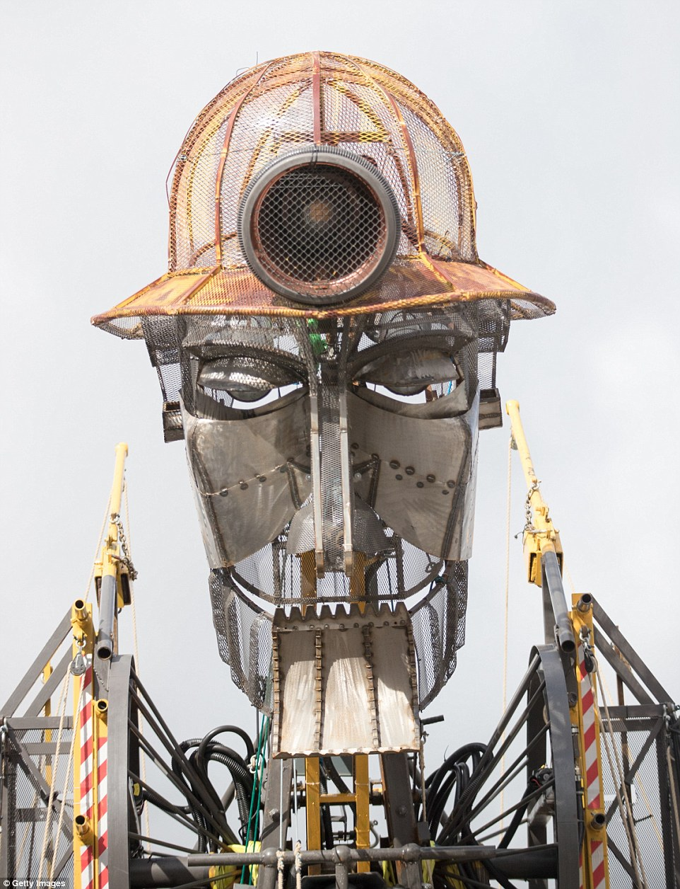

**Geometry: properties of shapes**

* identify and describe the properties of 2-D shapes, including the number of sides and line symmetry in a vertical line
* identify and describe the properties of 3-D shapes,  
  including the number of edges, vertices and faces
* identify 2-D shapes on the surface of 3-D shapes, [for  
  example, a circle on a cylinder and a triangle on a pyramid]
* compare and sort common 2-D and 3-D shapes and  
  everyday objects

**Geometry: position and direction**

* order and arrange combinations of mathematical objects in patterns and sequences

**Religious Education**

**Why is Cornwall special?**

**Cornwall as a place of spiritual inquiry**

Holy Wells

Celtic crosses

Cornish Saints

Standing stones.

**The Christian way of life**

Famous people who set an example for others to follow e.g. Saint Petroc (retellting of the story of St Petroc and the Fawn)

**Cornwall as a place of spiritual inquiry**

Festivals –10th February The St Ives Feast is an ancient tradition that celebrates the anniversary of the consecration of the Parish Church of St Eia in 1434

**MUSIC/Drama**

The children will have the opportunity to watch a performance from Kernow King based on Richard Trevithick and the Puffing Devil. They will have the opportunity to take part in a short workshop to dramatize the story using musical instruments to enhance the performance.

**ICT- Discovery coding**

Understand what algorithms are, how they are implemented as programs on digital devices, and that programs execute by following a sequence of instructions.

**PE-Expert PE Teacher from St Ives**

**Gymnastics Unit-stretching and curling.**

To remember movements to show others and describe the differences and suggest improvements

To link actions neatly and keep start and finish positions still.

To create a gymnastic sequence using the floor and apparatus of 4 different actions.

**English & Spelling / Grammar**

**Whole class guided reading text- The Iron Man by Ted Hughes.**

**Talk for Writing Unit based on THE MAN ENGINE REMEMBERED by Will Coleman**

***Genre: Stories involving Fantasy***

Daily retelling of the text with actions with supplementary drama based activities such as role play, role on the wall, hot seating, freeze frame, and conscience alley.

Week 1- Write a newspaper report based on the events in the story of the Man Engine.

Week 2-Recount the story of the Man engine from a different perspective.

Week 3- Write a letter to the Man Engine asking questions about his past.

Week 4-Write a recount based on a real like experience- visit to Geevor Tin Mine.

Week 5- Write a non-chronological report based on Cornish Mining Heritage

**MATHS**

Number and place value

* count in steps of 2, 3 and 5 from 0 and in tens from any number, forward and backward

**Multiplication and division**

* recognise odd and even numbers

Measurement

* recognise and use symbols for pounds (£) and pence (p); combine amounts to make a value
* find different combinations of coins to equal the same  
  amounts of money
* solve simple problems in a practical context involving  
  addition and subtraction of money of the same unit,  
  including giving change

**Seasonal Enrichment**

Poldark will visit Geevor Tin Mine to explore the Cornish heritage, conditions for the miners and have a chance to use equipment and go underground!

A Mining Engineer will visit to talk about a career in mining and the children will have the opportunity to find out about how and why mining is valuable to the economy and society.

|  |  |  |  |
| --- | --- | --- | --- |
| **St Uny C of E Academy** Image result for aspire academy trust | | | |
| **Term: Spring 1** | **Year: 2019/2020** | **Teachers: Steph Wetherelt** | **Year Groups: Year 2** |
|  | **TOPIC: A Blast from the Past – Cornish Mining** | | |
|  | | | |