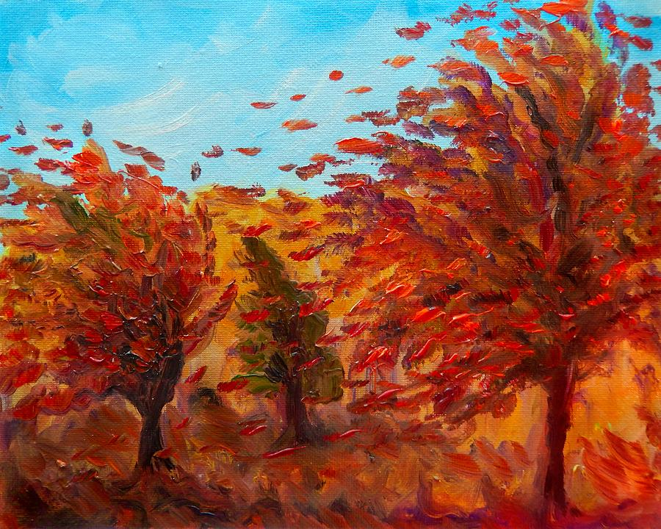
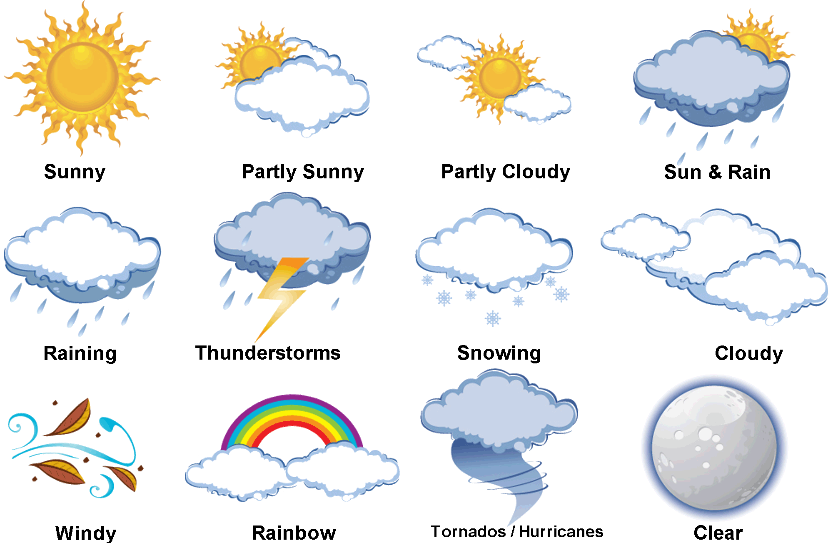
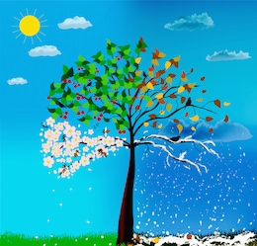
Blown Away!

Y 1/2 Overview
Autumn 1 2018

In YEAR 2 maths lessons we will be ensuring that we can:
- Count in steps of 2, 3 and 5 forwards or backwards
- Read and write numbers to 100 in numerals and words.
- Recognise the place value of each digit- tens and ones
- Identify and represent number using images, objects and number lines.
- Use > and < and = signs to compare numbers to 100
- Recall addition and subtraction facts to 20 and then 100
- Add and subtract numbers mentally and recognise inverse relationship between them.
- Recall the 2, 5 and 10 times table.

In YEAR 1 maths lessons we will be ensuring that we can:
- Count to 20 forward or backwards, write all numbers to 20 in words and numerals.
- Give a number one more and one less.
- Multiplication- Count in multiples of two
- Represent and identify numbers using images and objects.
- Use number bonds to 20
- Subtract one or two digit numbers to 20
- Interpret the mathematical symbols addition/subtraction/equals.

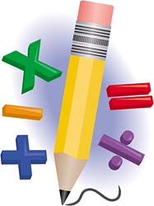

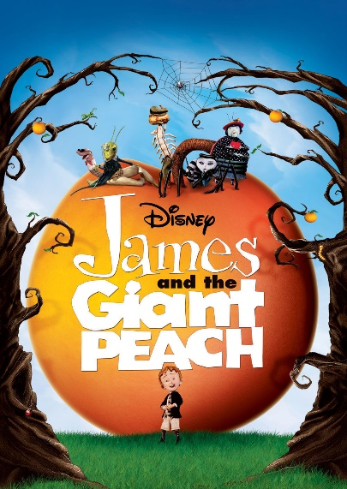
In English we continuing with Read Write Inc. for phonics provision and will be regularly assessing and grouping the children. We will also be launching our new reading scheme to supplement our Read Write Inc. scheme. The children will also have access to the library each week where they can choose a book for their own enjoyment. Reading comprehension and guided reading will be taught alongside RWI as will regular spelling lessons.
As part of our topic we will be retelling the story of James and the Giant Peach, creating our own poems with a weather theme based on poetry of Christina Rosetti. For speaking and listening the children will work collaboratively to create an interactive weather report and will have the opportunity to film themselves using the ipads.
Our Science learning will look at how observe local weather as well as collecting data daily based on our observations. We will introduce and describe the changes in seasonal weather across the year. The children will learn how to read a thermometer to record the daily temperature and a scale to read rain fall. We will discover the best material for an umbrella thinking about its properties- then have fun testing them out!

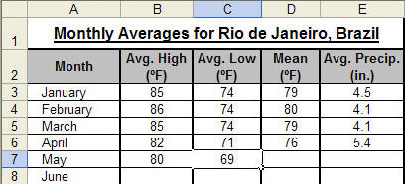
In Computing we will learn how to use a spreadsheet to record data based on the children’s weather observations. We will also be introducing ‘Discovery Coding’ as part of our programming and computing syllabus.

In music

In Geography we will be studying different climates across the globe. We will explore the South and North Pole and identify the equator. The children will learn about why there is different climates/weather conditions in different areas of the world

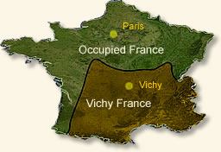

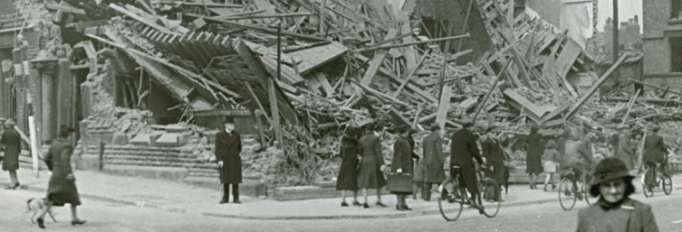

In RE we will be looking at Judaism, with links to our class novel The Boy in the Striped Pyjamas. Our theme is called Lest We Forget, and we will be learning about the Holocaust using material appropriate for Y6. We will also be following the Understanding Christianity Unit How can Following God bring Freedom and Justice? and preparing for our Harvest Festival.

In PHSCE we will be focussing on the start of a new and important school year, with discussions on our responsibility in school to ourselves and others. We will learn about resilience and perseverance.
Our Art lessons for this half term will be inspired on the wartime sketches of Henry Moore. We will be learning how to use pencil techniques to show light, shadow and emotions in our drawings. In DT we will be making a weather vane to measure wind direction and a rain gauge to measure the amount of precipitation.
Our experiences this term will be
A trip to experience the Blitz at Flambards.
A themed wartime tea treat for families to share in our learning and be entertained.
Dates will be shared as soon as possible.

If you have any artefacts that would support our learning this half term, or any expertise in any of the areas we are studying, please see Miss Hill about sharing with the class.
Our learning in Foreign Languages will continue with Mrs Full from St Ives School.
In PE

