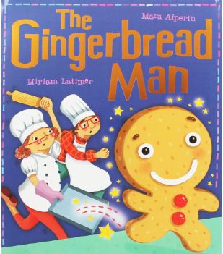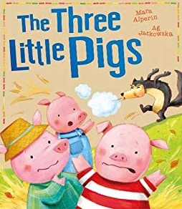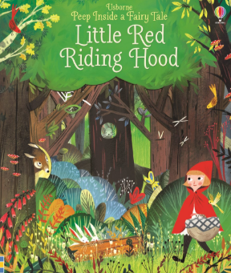

**Seasonal Enrichment**

Forest School

We will be attending a local Forest school. While there, the children will collect evidence by using their senses to describe a setting, with a direct link to our ‘Once Upon A Time’ topic.

**English & Spelling / Grammar**

**English/Spelling/Grammar**

Daily RWI Phonics, comprehension challenges linked to a read text, short film and images, common exception word practice, daily handwriting and SPaG challenges throughout lessons.

**1 Week – Story writing**

Imitate, innovate and invent their own stories and share with the class using a story map and a story organiser.

**Non-Fiction**

Writing a set of instructions to support our Gingerbread Man design. Writing a recount of our Half-Term holiday.

**2 Week Fiction – Traditional Tales**

Character descriptions, writing a description of a setting from the viewpoint of a main character, creating wanted posters, writing a letter from a traditional tale character to another, sequencing a traditional tale, think, say and feel – looking at the feelings of characters, retelling traditional tales from what has been heard.

**Religious Education**

**We will be looking at Salvation and answering the question why does Easter matter to Christians?**

We will be learning and sequencing the story of Easter.

We will be writing a description of Salvation and why ultimately why it matters to Christians.

We will be making Easter cards to give to our family.

**PE**

We will be developing our swimming skills, strength and stroke in the water.

**SPIRITUALITY**

Windows

Mirrors

Doors

**GEOGRAPHY**

**Identify and seasonal and daily weather patterns in the United Kingdom and the location of hot and cold areas of the world in relation to the Equator and the North and South Poles.**

We will be sorting weather into categories that happen in the UK, sometimes happens and doesn’t happen.

We will be investigating weather associated with hot and cold and the links across the World.

Furthermore, we will also look at how we can prepare ourselves for the different seasons.

**HISTORY**

N/A

**SCIENCE**

**Observe changes across the seasons and describe the weather associated with the seasons and how day length varies.**

The class will participate in science week and they will study the days of the week whilst keeping their own weather diary and making predictions about each day using the correct weather symbols.

Deliver a weather report to the class.

We will look at how day length varies across the year and why this happens.

**MUSIC**

N/A

**BRITISH VALUES**

The class will look at friendship this half term and how people show it, how we can show it and how the wider world shows it through PSHE.

**Strand:**

**Measurement: Length & Height**

We will be measuring and beginning to look at and record lengths and heights.

We will be comparing, describing and solving practical problems for: lengths and heights including long/short, longer/shorter and tall/short.

**Strand:**

**Measurement: Weight & Volume**

We will be measuring and beginning to record mass/weight, capacity and volume.

We will be comparing, describing and solving problems for mass and weight including heavy/light, heavier than/lighter than, full, empty and half full etc.

**MATHS**

**ART AND DESIGN/ DESIGN AND TECHNOLOGY**

**Select from and use a wide variety of materials including ingredients according to their characteristics.**

**Select from and use a range of tools and equipment to perform practical tasks.**

Designing and cooking some gingerbread men, linked to our topic.

Review and evaluate our gingerbread men.

We will be making Easter cards to give to our family.

**COMPUTING**

**Understand what algorithms are and create simple programs.**

We will continue to look at algorithms and programs and develop our directional skills ready to create our own instructions towards the end of the term.

**Strand:**

**Number: Place value (to 50)**

Count to 50 forwards and backwards, beginning with 0 or 1, or from any number.

Count, read and write numbers to 50 in numerals.

We will also continue to identify one more or one less than a number from 0 – 50.

Count in multiples of two, fives and tens.

|  |  |  |  |
| --- | --- | --- | --- |
| **St Uny C of E Academy** Image result for aspire academy trust | | | |
| **Term: Spring 2** | **Year: 2018/2019** | **Teachers: Mrs Trenerry & Miss Smitheram** | **Year Groups: 1 Tehidy** |
|  | **TOPIC: Once Upon A Time** | | |
|  | | | |