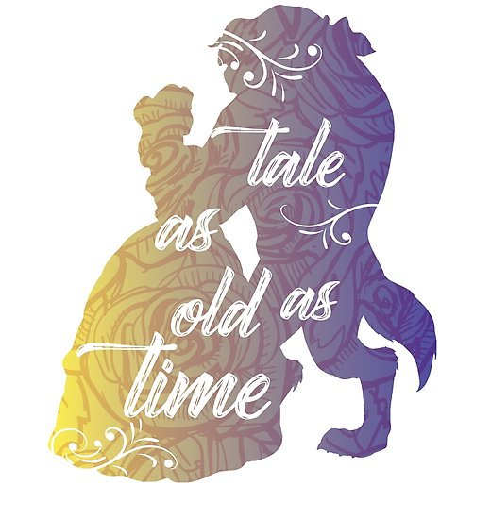

**HISTORY – The History & Life of Walt Disney**

Researching and writing about the life of Walt Disney, including his films and theme parks.

**SCIENCE – WEATHER**

To observe changes across the seasons, observe and describe weather associated with the seasons and how the day length varies.

To name and describe the four seasons.

To know that tools are used to gather information about the weather.

To present data using a graph.

To understand different types of clouds.

To understand that weather forecasts help people to prepare for different kinds of weather.

**Addition and Subtraction (11-20)**

* Count forwards and backwards beginning at 0 or 1 from any given number.
* Count, read and write numbers to 20 in numerals and words.
* Given a number, identify one more or one less.
* Identify and represent numbers using pictorial representations including number lines and use the language of: equal to, more than, less than or fewer, most and least

**Religious Education**

**Incarnation Unit – November**

**Why does Christmas matter to Christians?**

Give a clear, simple account of the story of Jesus’ birth and why Jesus is important for Christians.

Recognise that stories of Jesus’ life come from the Gospels.

Give examples of ways in which Christians use the story of the nativity to guide their beliefs and actions at Christmas. Decide what they personally have to be thankful for at Christmas time.

**Introduction to Judaism (January- February)**

Jewish belief about G-d

G-d is One, good

G-d is creator

G-d cares for all people

Belief exemplified through: The Shema, mezuzah, tefillin, tzizit, the first of 5 commandments, prayer, psalms and songs, stories, wearing of kippah and tallit.

Festivals and celebrations

Pesach, Shavuot and Sukkot.

Worship and the community

The synagogue: the community centre; place of prayer and study; its main features and components; historical developments, the role of the Rabbi.

**English & Spelling / Grammar**

Daily RWI Phonics, Guided Reading / Cracking comprehension(weekly)/ Handwriting.

SPAG Emphasis for Year 2.

**2 Weeks Fiction – Storytelling into Writing: Beauty and the Beast.**

Focuses: character and settings descriptions, recount writing, poetry writing with the senses, imitation, innovation & inventions.

**2 Weeks Letter Writing & Newspaper Reports**

Newspaper reports about the kidnapping of Belle and letters to the Beast asking him to release her.

**1 Week – Poetry & Riddles**

Linked to characters and story elements.

**PE**

Multi-skills, Dance, Gymnastics.

**Outdoor Opportunities**

Links to Geography – map skills locally, forest school sessions . Setting of the woods in Beauty and the Beast – real life experience for writing.

**Addition and Subtraction**

* Represent and use number bonds and related subtraction facts within 10
* Read, write and interpret mathematical statements involving addition (+), subtraction (-) and equals (=) signs.
* Add and subtract one-digit numbers to 10, including zero.
* Solve one step problems that involve addition and subtraction, using concrete objects and pictorial representations and missing number problems.

**SMSC**

To take part in activities for Children in Need. Taking part in a democratic process (selecting school councillors. Writing a letter to a local MP. Visiting a local care home to sing and talk to residents.

**COMPUTING**.

Programming and algorithms using apps on iPads. Writing a set of instructions for a partner to complete a simple algorithm.

Link to Literacy instructions writing.

**MATHS**

**Shapes**

* Recognise common 2-D shapes (rectangles, squares and triangles)
* Recognise common 3-D shapes ( cubes, cuboids, pyramids and spheres)

**ART AND DESIGN**

* Create a stained-glass window using mixed media – black card, tissue paper and adhesive paper taken from a scene from Beauty and the Beast.
* Research Louis Comfort Tiffany (stained glass windows)
* Christmas card design
* Enterprise DT project for xmas fair- Reindeer food/Hot chocolate cocoa cones.

**GEOGRAPHY – Disney Castles**

Researching the location of the Disney theme parks, placing them on a map and identifying the cities and countries.

**MUSIC**

Play and perform sequences of music, listen to and respond to pieces of music

Learn the songs for our nativity.

**BRITISH VALUES**

To develop an acceptance that other people having different faiths or beliefs to oneself (or having none) should be accepted + tolerated & should not be the cause of prejudicial or discriminatory behaviour. CHILDREN IN NEED & planning and leading a class assembly.

|  |  |  |
| --- | --- | --- |
| **ST Uny C of E Academy** | | |
| **Winter curriculum NOV- JAN** | **Year: 2018/2019** | **Teacher: Miss Wetherelt YEAR 1** |
|  | **TOPIC: TALE AS OLD AS TIME** | |
|  | | |