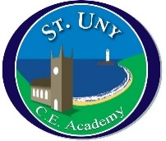
St Uny Church of England Academy
School Council Meeting
Date: 08.11.21

1 | Children in Need  organisation | Dressing up in house colours.  Classes can decide to do either a 5-minute dance off in the hall or a 5-minute circuit activity – classes to vote and decide before they go in.  School councillors to help set up at 2.30 on Friday afternoon.  SC to ask Kirsty about whether we need ingredients lists to put on cakes that are sold.  Decided to let parents know with a newsletter post JT to ask Mrs Olney about the newsletter.  MP to tell Mr Hoskins our plans for the day and ask him to put on newsletter.
2 | Eco council | MP and JT have started to do an eco-health check. They are 60 questions in and have 40 left to go!  School Councillors to collect ideas on the following questions.  So far – we don’t have enough bins. How can we make the bins better?  M and J will investigate renewable energy.  How can we encourage more people to walk or bike to school?
3 | Feedback | Miss Hill to give school councillors a copy of the minutes after each meeting to feedback to their classes.  School councillors will ask their class teachers for a time to talk about the meeting.
4 | AOB | MP to ask if there is any money to spend on the library as she has noticed the baskets are rusty and broken.  Please remind children that there is a healthy snack policy at breaktime – only vegetables or fruit.

