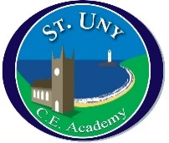
St Uny Church of England Academy
School Council Meeting
Date: 19.10.21

1 | Election of officers | - Officers for the coming year were elected.  Chair – LD  Vice Chair – SC  Secretary – AT  Vice Secretary – BD  Treasure – TD  Vice Treasurer – MP  Layla then ran the meeting.
2 | Children in Need | A vote was taken to decide on how we would raise money for Children in Need.  A non-uniform day with children asked to dress in house colours / house dressing up.  Cake sale to take place after school.
3 | Charity for the year | - Councillors were asked to go back and ask their classes for ideas about which charity to support in the coming year.
4 | AOB | Next meeting 16th November 2021

