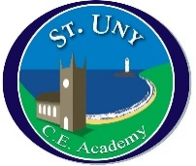
St Uny Church of England Academy
School Council Meeting
Date: 10.01.22

1 | Charity choice | Children’s Hospice SW  School councillors chose to support the above charity over the year.
2 | Eco council update | Any news Jasper and Molly?  Haven’t had time too do any but will have done some more by the next meeting.
3 | Mental Health | What are we doing to support Children’s mental Health this half term!  School trips to be taken this term.  Sing off….  Forest School for all classes by end of this year  Colour run soon  What else would classes like to do to improve positive mental health?
4 | AOB | What can we do to improve the splat playground?  Who should use it? What equipment do we need there?

