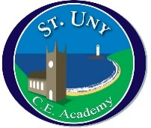
St Uny Church of England Academy
School Council Meeting
Date: 07.03.22

1 | Comic Relief Organisation  18/03/22 | Dress up in pyjamas  Cake sale  Joke telling in classes – everyone brings in a joke – best one from each class to be put in the newsletter.
2 | Mental Health | Singing  Play  Healthy breaks  Craft and art opportunities  We love dressing up!
3 | Next Fundraiser | Our chosen charity is Children’s Hospice SW and after Easter we plan to do a Break the Rules Day to raise money – we will check with Friends of St Uny to make sure we don’t clash with them.
4 | AOB | Outside toilets – these have not been cleaned for ages – there are going to be changes to our cleaners and this will be sorted soon.  If there are any more issues around school please tell your school council rep who will feed back to us at the next meeting after Comic Relief.=
=

